Threats and Countermeasures – Lecture 5 Execution
Execution
- “Execution consists of techniques that result in adversary-controlled code running on a local or remote system.”
Usually via External Access
- Taking advantage of an intentional service.
  - Leveraging weakness in a server
CVEs
- Common Vulnerabilities and Exposures
  - (Semi)Structured vulnerability details
  - Includes a score/rating based on the Common Vulnerability Scoring System
  - CVSS 3.0 - Score (1-10), Rating (Low, Medium, High, Critical)
CVSS
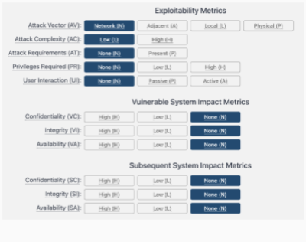
ExternalBlue (CVE-2017-0144)
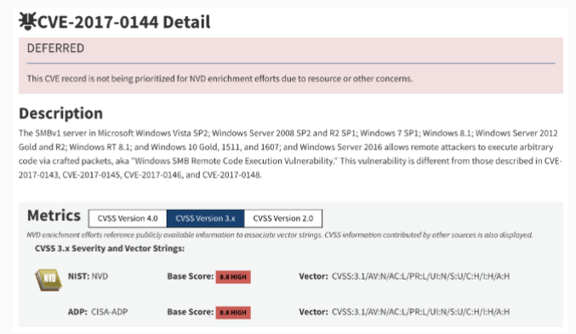
ExternalBlue
- 2008 Vulnerability introduced to all SMB
- Pushed to all Microsoft products (Windows XP/Vista/7/8/10, etc.)
- 2010 NSA finds and weaponizes
- 2016 NSA loses their exploit & tooling
ExternalBlue Impact
- May 2017 – bolted to WannaCry’s Ransomware worm and deployed. Hits hospitals, telecom, manufacturing...
- June 2017 – bolted to Petya/NotPetya Ransonware worm and deployed. Hits power companies, shipping companies, major banks, ISPs
Pre-built Exploit Templates
- Exploit Database
- GitHub
Via External Access
- Taking advantage of an intentional service.
  - Leveraging weakness in a server
- Primary causes of vulnerabilities
  - Insecure implementation
  - Insecure configuration
  - Misunderstood admin assumptions/expectations
  - Exposed APIs/Microservices
- Interrogation and investigation is readily available as deployed!
Pre-made Vulnerability Scanners
- Burp Suite
- Nesus
- Mayhem/ForAllSecure
Via Clients Attack Surface
- Leveraging weakness in a target’s clients
- Primary causes of vulnerabilities:
  - Insecure implementation
  - Insecure configuration
  - Misunderstood admin assumptions/expectations
  - Exposed APIs/Microservices
- How does a client’s attack surface differ from a server?
- Targets rely heavily on a small set of predictable and widely available applications!
Client Services
- Web browsers
- Email
- Office Applications – Macros
- PDF readers
Via Automation Tooling
- Leveraging own toolchain against target
  - 3rd party management, monitoring, deployment tools have pre-existing access
  - System configuration manager
  - Patch manager
  - Bamboo
  - Jenkins
  - Ansible, Puppet, Chef
  - Cloudflare
Via Command/Scripting Interpreters
- Often called “shells”
  - Unix shells (C shell, BASH, ZSH)
  - Applescript
  - Powershell
  - CMD
  - VisualBasic
  - Python/Javascript/Lua
- Netcat
  - Raw TCP/UDP socket application
  - Almost universal with Linux installations
  - Assorted versions: nc, netcat, ncat, socat
- Direct shell – SSH
- Forward/bind shell
- Reverse/Callback shell
Red Team Methodology
- Recon:
  - Nmap -sn : find the IP
  - Nmap -sT : find the TCP ports
  - Nmap -sU : find any UDP ports
- Initial Access:
  - Check any services found to validate
  - Find initial access points
- Recon:
  - From that access point, what can I learn?
  - Search for CVE, exploits
- Execution:
  - Can I get execution anywhere?

